

National University of Modern Languages (Main Campus)
Department of Software Engineering
Presentation Report
Chapter:05
Business Process Engineering
Submitted By:
- Zahra Eman
- Saiqa Manzoor
- Mehwish Aslam
Roll number:
- SP-23721
- SP-23677
- SP-23719
Submitted to:
- Sir Col. Sial Bakhsh
Date of submission:
- October 13, 2024

- Introduction:
This chapter explains how organizations measure their performance to track how well they are doing. Some companies have advanced systems to get real-time data, while others check their progress at the end of each week or month. Performance information helps companies understand their markets and processes, which is why many invest in improving these systems.
In the past, there was a gap between what executives and operational managers cared about. Executives focused on financial performance, like profits and stock prices, while operational managers looked at the day-to-day work, like product quality and customer satisfaction. Traditionally, companies divided their work into departments based on skills, but these departments don’t always connect well with the overall goals tracked by executives.
To address this, companies started moving toward managing entire product lines or processes. By looking at the whole process, managers can better understand how changes in work affect costs and sales.
- Key Measurement Terms:
This section defines key terms used in measuring performance:
- Unit of measure: The type of data being tracked (e.g., sales, cash flow).
- Target: The specific goal you aim to reach (e.g., $28 million in monthly cash flow).
- Timeframe: When the measurement happens (e.g., monthly or quarterly).
Other important terms include:
- Goal: A desired outcome (e.g., being profitable).
- KPI (Key Performance Indicator): Similar to a goal, used to track performance.
- Vision statement: A long-term goal (e.g., being the most profitable by 2025).
- Objective: A measurable target with a set time and goal (e.g., achieving $28 million in cash flow monthly by the end of the year).
- Data: The raw numbers used to track if goals or targets are met.
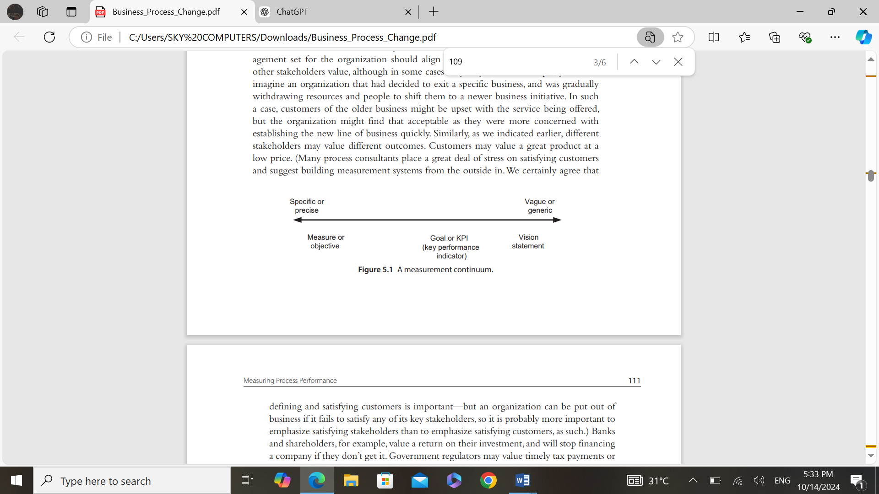
Different stakeholders (customers, employees, investors) value different things, so performance measures should balance all their needs. For example, customers might want low prices, but investors might care more about profits, and both must be considered.
- Internal and External Measures:
This section explains the difference between internal and external measures of process performance:
- External measures: These show the results of a process and tell if it satisfies customers, shareholders, or other stakeholders. Examples include income, customer satisfaction, market growth, and stockholder confidence.
- Internal measures: These focus on how a process works within the company, such as efficiency, cost, and quality of internal outputs.

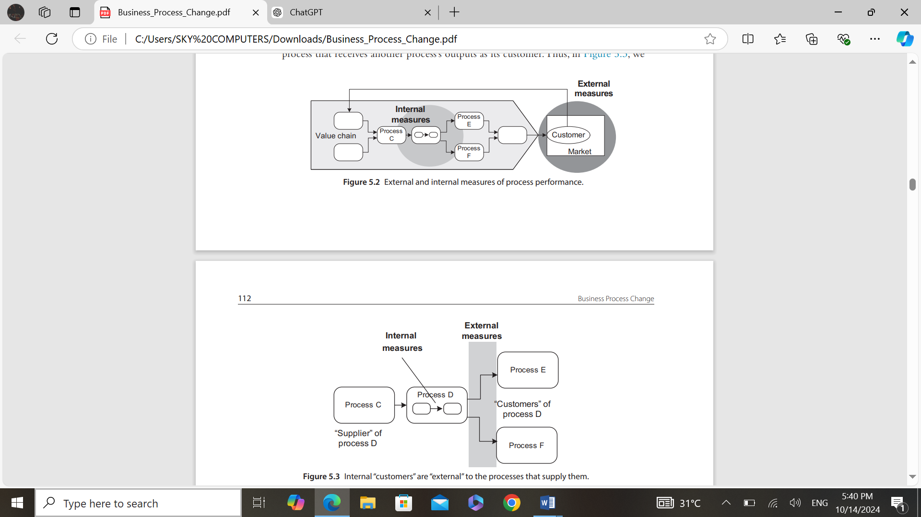
The key idea is that “external measures” are the ultimate way to judge success. If a process satisfies external stakeholders, then the focus can shift to improving internal measures. But improving internal efficiency without considering external results (e.g., customer satisfaction) can lead to problems. For example, one company cut costs too much, which led to unhappy customers. They had to change their approach, ensuring customer satisfaction was prioritized before cutting costs again.


- Leading and Lagging Indicators:
Lagging indicators: These tell you what has already happened, but you can't change the result. For example, knowing how many sales you made after the quarter is over doesn't help you change anything.
Leading indicators: These help predict future outcomes and allow you to take action. For example, tracking how many sales calls are scheduled can give you an idea of how many sales you'll make and help you make adjustments in time.
In a sales example, if you know that 100 leads result in 1 sale, and your goal is to increase sales by 15, you'll need 1500 more leads. By tracking leads early in the quarter (a leading indicator), you can adjust your efforts if you're not on track, giving you time to improve before the quarter ends.
In short, leading indicator help managers take action to meet goals, while lagging indicators only show results after the fact. Ideally, you track both, but leading indicators are more useful for making adjustments.
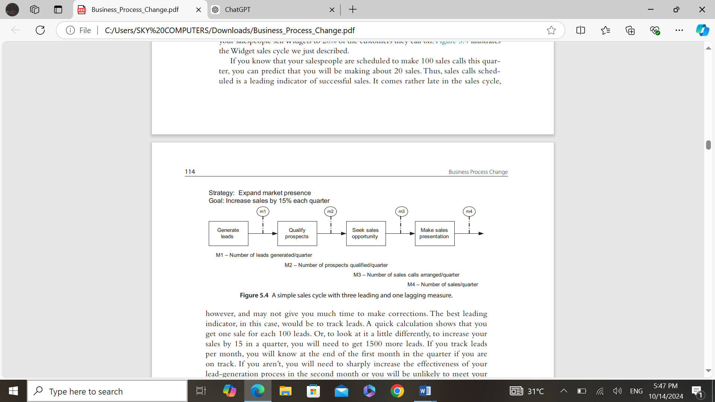

- Developing a Comprehensive Measurement System:
Many organizations fail to organize all their performance measures into a clear system, leading to confusion among managers and employees. They might set goals for different departments or customers but not for processes, or focus on financial goals without connecting them to the processes that drive success.
This creates confusion if goals aren't balanced and prioritized. At the enterprise level, it's important to build a measurement system that links strategic goals, stakeholder needs, and internal process goals into one clear and consistent framework.

- Balanced Scorecard and Process Measures:

1. Overview of Balanced Scorecard:
- The Balanced Scorecard, popularized by Kaplan and Norton, serves as a strategic management tool to improve organizational performance.
- It addresses the limitations of traditional financial metrics by incorporating multiple perspectives, helping organizations align their actions with strategic goals.

2. Four Perspectives of the Balanced Scorecard:
- Financial Measures:
- Focuses on how the organization appears to shareholders.
- Key metrics include return on investment (ROI), cash flow, and operating income.
- Helps assess the financial health and sustainability of the organization.
- Customer Measures:
- Evaluates how customers perceive the organization and its offerings.
- Metrics include customer satisfaction, retention rates, and market share.
- Essential for understanding customer needs and enhancing loyalty.
- Internal Business Processes:
- Identifies critical internal processes that must be excelled at to achieve strategic objectives.
- Metrics might include cycle time, cost efficiency, and quality control.
- Focuses on operational excellence and process improvements.
- Innovation and Learning:
- Measures the organization’s capacity for innovation and continuous improvement.
- Metrics can include the number of new products developed, employee training hours, and knowledge management initiatives.
- Ensures the organization can adapt and thrive in a changing environment.
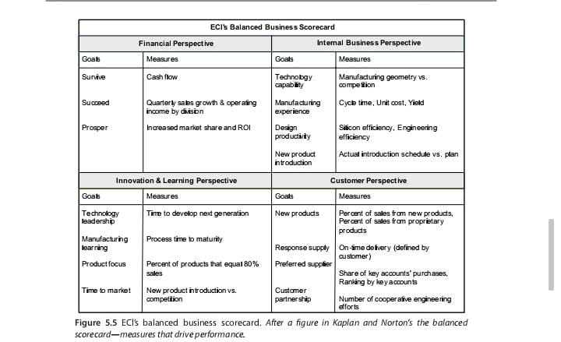

3. Importance of Measurement:
- Kaplan and Norton emphasize that "what you measure is what you get," highlighting the need for a balanced approach to avoid the pitfalls of focusing solely on financial outcomes.
- A comprehensive measurement system encourages behaviors that foster innovation and customer satisfaction, critical for long-term success.

4.Linking Measures to Strategy:
- Effective implementation of the Balanced Scorecard requires linking performance measures directly to corporate strategies.
- This involves defining specific goals for each of the four perspectives that align with strategic objectives.
- Kaplan and Norton introduced Balanced Scorecard Strategy Maps to visually depict these linkages, illustrating how different measures contribute to overarching strategic goals.
- Organizations must ensure that lower-level measures and goals reflect and support the higher-level strategic objectives, creating a coherent framework for performance evaluation.

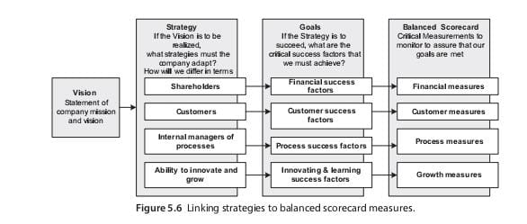
- Balanced Scorecard Strategy Maps:
The Balanced Scorecard Strategy Map is a visual tool used to illustrate the relationships between an organization’s strategic objectives across the four perspectives of the Balanced Scorecard: Financial, Customer, Internal Business Processes, and Innovation and Learning.

Benefits:
- Enhances clarity and understanding of strategic goals.
- Improves communication across the organization.
- Facilitates performance monitoring and progress tracking.
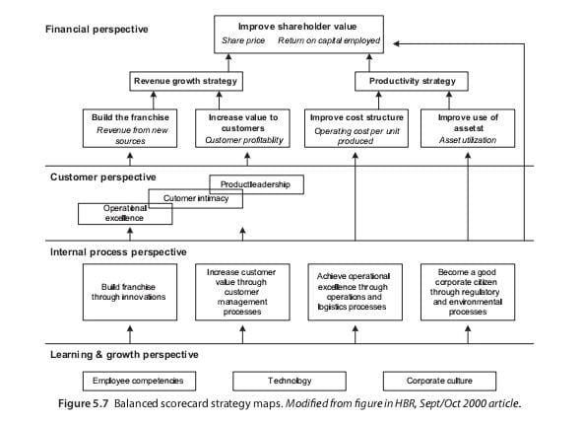

5. Functional vs. Process Goals:
- Functional goals focus on the specific targets of individual departments, often prioritizing their own success.
- Process goals emphasize collaboration and alignment among departments to achieve the overall objectives of the organization.
- Focusing too much on functional goals can create silos, making it harder for departments to work together effectively.
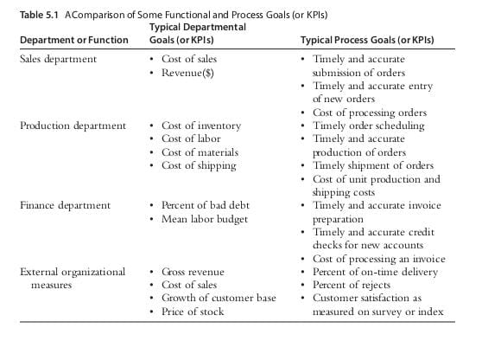

6. Matrix Organization Approach:
- Some organizations are exploring matrix structures where managers are accountable for both functional and process metrics.
- This dual accountability encourages managers to consider the entire value chain, promoting collaboration and shared responsibility for outcomes.
- Such structures can help break down silos and foster a more integrated approach to performance management.

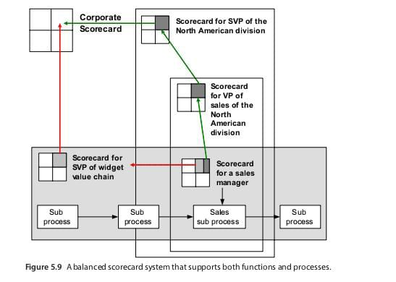

7. Aligning Process Measures:
- A case study example is Boeing’s C-17 project, which exemplifies a rigorous process-oriented approach.
- Each core process and subprocess is connected through contracts that specify expectations and deliverables.
- This ensures that managers understand what is required to meet downstream commitments, enhancing accountability and performance across the value chain.
- The alignment of measures creates a robust system where any failure in meeting contract obligations can be quickly identified and addressed.
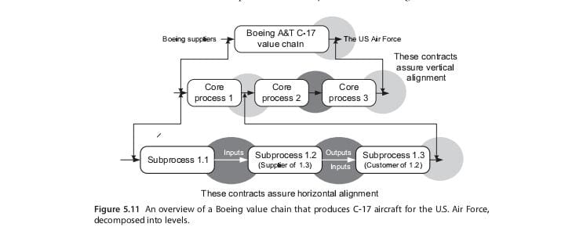

- DERIVING MEASURES FROM BUSINESS PROCESS FRAMEWORKS:
In the last chapter, when we discussed business process frameworks, we mentioned the fact that both supply chain operations reference model (SCOR) and VRM provide measures for each of their processes. Figure 5.12 provides an overview of the measures for the SCOR supply chain process. The five high-level SCOR measures are divided between external (customer-facing) and internal measures.
If a company uses a framework like SCOR to structure its business process hierarchy, then it can proceed to derive appropriate measures from the SCOR reference materials. The manual contains the definitions for all processes included in the SCOR framework, the metrics appropriate for evaluating each process at each level, and definitions of how each measure is to be calculated.

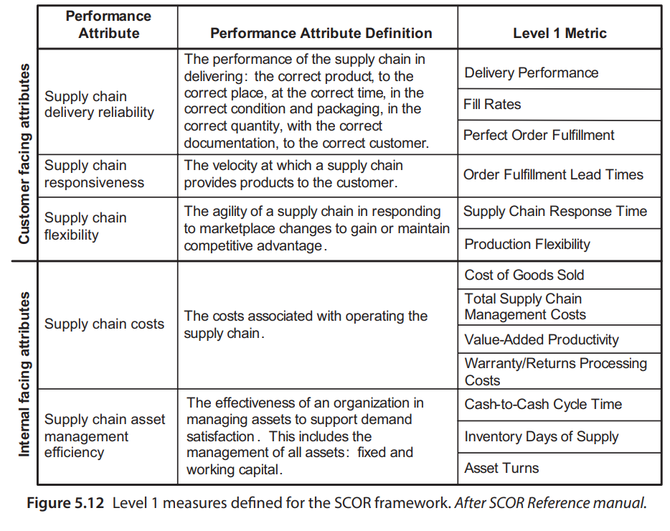

SCOR defines five generic performance attributes and then suggests appropriate metrics for each attribute.

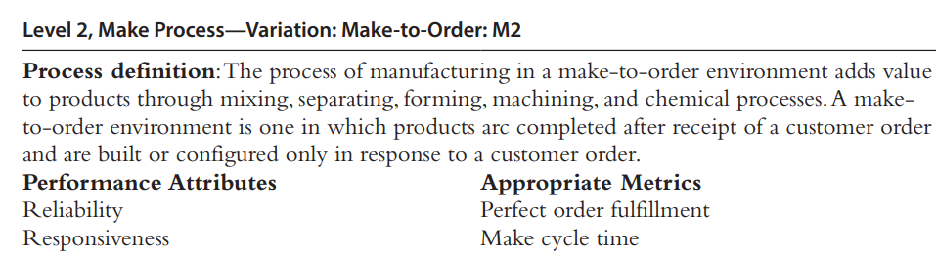

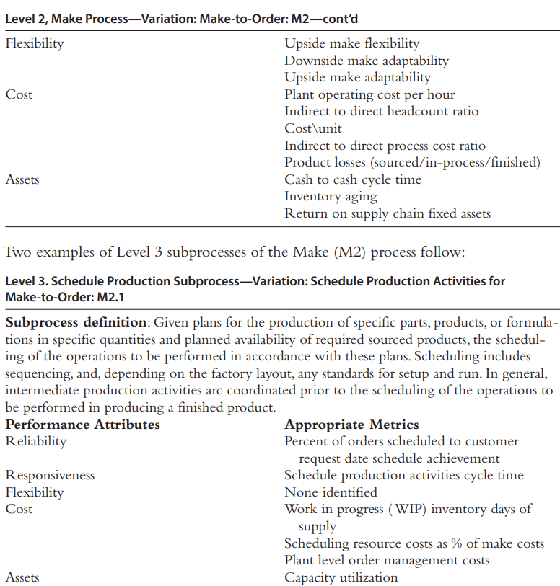

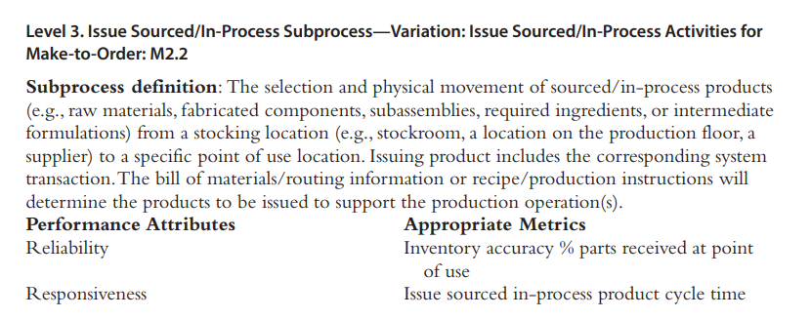

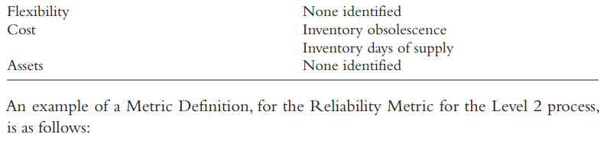

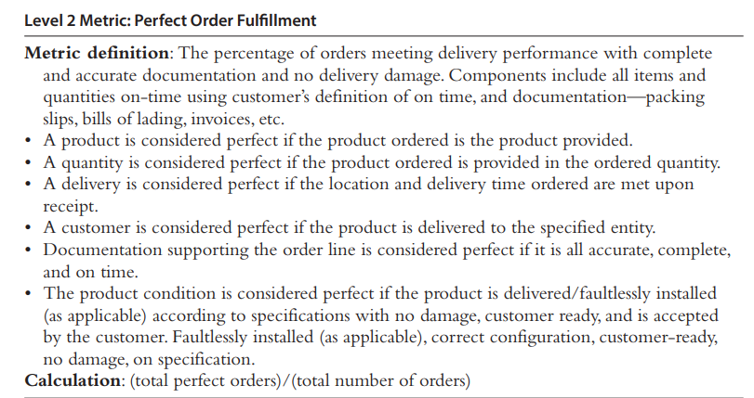

The Supply Chain Council not only provides a comprehensive set of measures for the processes included in their Supply Chain, Design Chain, and Sales and Marketing frameworks, but they also work with an outside benchmarking agency so that companies using the Supply Chain Council’s measures can get benchmark information on the same measures. To use the Supply Chain Council’s framework, measures, and benchmarks, an organization needs to join the Supply Chain Council. Once that is done, however, the company has free access to a comprehensive process measurement system that it can use to rapidly develop its own business process architecture.

- PUTTING IT ALL TOGETHER:
As we suggested at the beginning, most companies are still experimenting with process management and with the specification of process-based performance measures. Most companies tend to have measures defined at the lower process levels, but they don’t have performance measures at the value chain level. Moreover, they rarely have their measures tightly integrated with their strategic goals.

A few companies, like Boeing GMS, are far ahead of others, and have a rigorous process measurement system that runs from the top right down to the smallest process in the organization. Using contracts, the Boeing GMS system lines everything up and makes a rigorous traceability possible.
Figure 5.13 also suggests how we can get around the layered nature of the Balanced Scorecard strategy model.
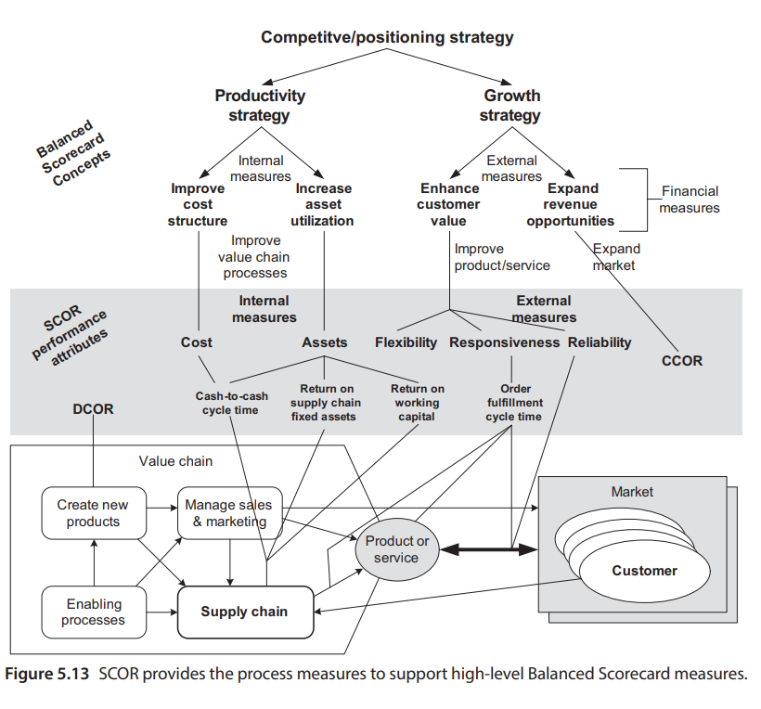

- COMPLETING THE BUSINESS PROCESS ARCHITECTURE WORKSHEET:

Now that we’ve reviewed some of the management and measurement issues that any company interested in developing a business process architecture will need to address, let’s return to the business process architecture analysis worksheet.
. We began by structuring all the worksheets with operational processes. The level 1 worksheets allow us to define the level 1 operational processes that make up a value chain. The level 2 worksheets focus on specific level 1 processes and allow us to define level 2 operational processes for each level 1 process. In each case, once we have defined the processes, we should identify the manager who will be responsible for each specific process and we should define the metrics or measures that we will use to determine if the process is accomplishing its goals and if the manager is doing his or her job effectively.

_____________________________________________

